**Lab – 5: How to assign a user to administrator roles in Azure Active Directory?**

**Objective:** The objective of this lab is –

* To assign a user to administrator roles in Azure Active Directory.

If you have already added users in Azure AD but have not given the administrator permissions, so you can assign roles to them at any time. In this lab, we are going to assign the Password Administrator role to an added user. Users with Password Administrator role can reset passwords, manage service requests, and monitor service health. Password administrators can reset passwords only for users and other password administrators. Using Azure Active Directory (Azure AD), you can designate separate administrators to serve different functions.

**Prerequisite:** EMS Enterprise Mobility + Security E5.

**Steps:**

1. Sign in to your Azure Portal, by using the link - **https://portal.azure.com/**. Enter your credentials and click Sign In.

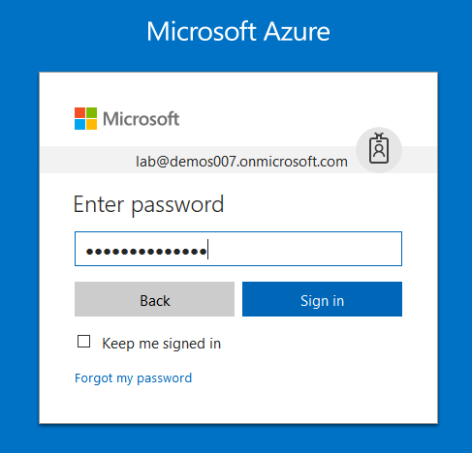

1. Microsoft Azure AD Dashboard will open.

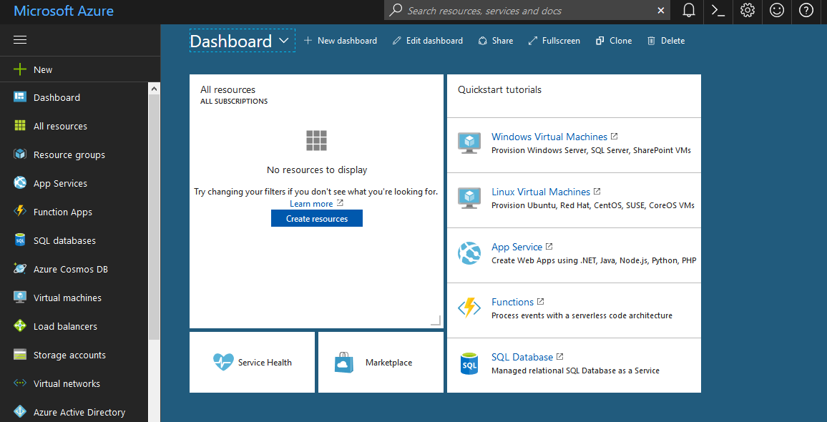

1. Now click **Azure Active Directory** from left-hand pane, and then select **Users and groups**.

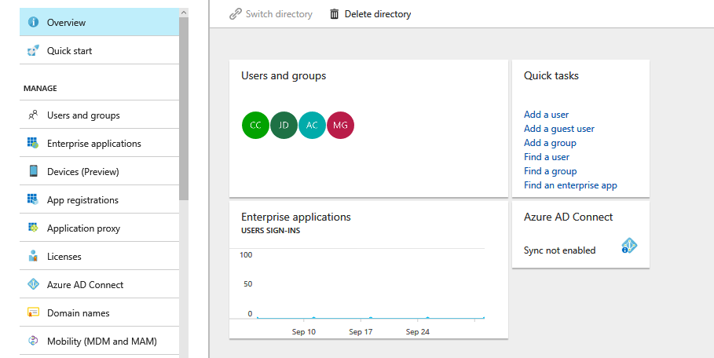

1. On **Users and groups**, select **All users**.

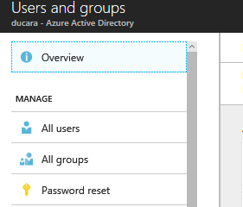

1. And, then select any user to which you want to assign a Password Administrator role in Azure Portal. Here, I am selecting **Jack Daniel**.

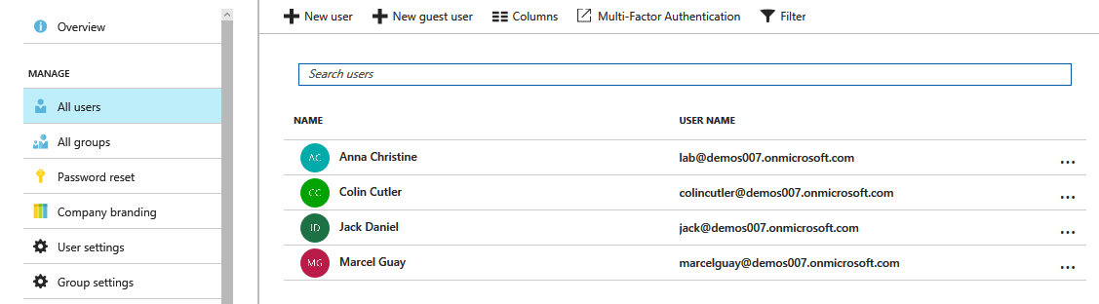

1. User (here, Jack Daniel) profile will open which shows the complete details about that user.

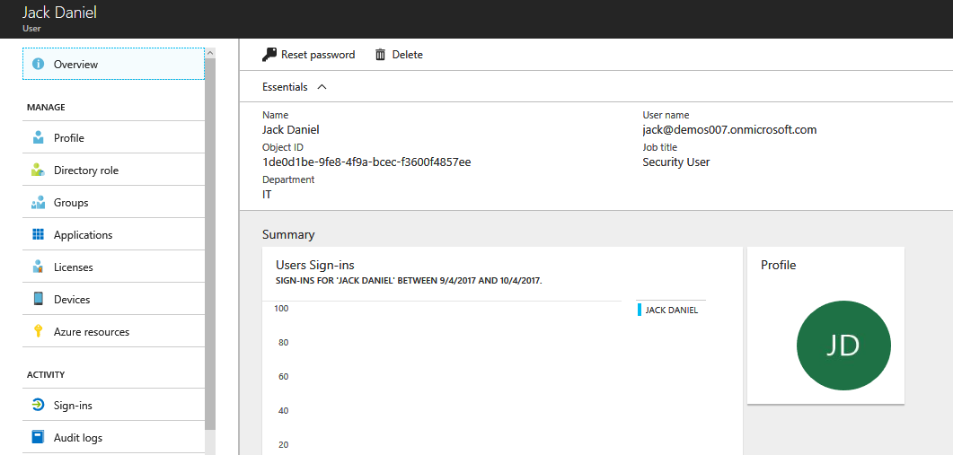

1. On the blade for the selected user, select **Directory role**. Now, assign the user to a role from the **Directory role** list. Here, you can see all the roles that you can assign such as – User, Global Administrator or Limited Administrator.

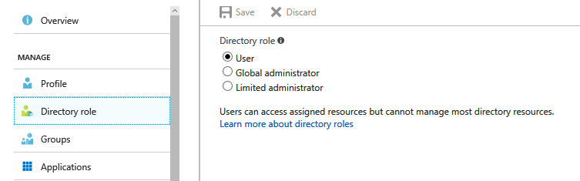

1. Click **Limited Administrator**, and you will get all the administrator roles that you can assign to the user. Like - Password administrator, Service administrator, Billing administrator, Exchange administrator, Skype for Business administrator, User administrator, SharePoint administrator, Compliance administrator, Security reader, Security administrator, Privileged role administrator, Intune Service administrator, Guest inviter and Conditional Access Administrator. So, these are the roles which you can assign to a particular user. You can assign more than one role also to a particular user.

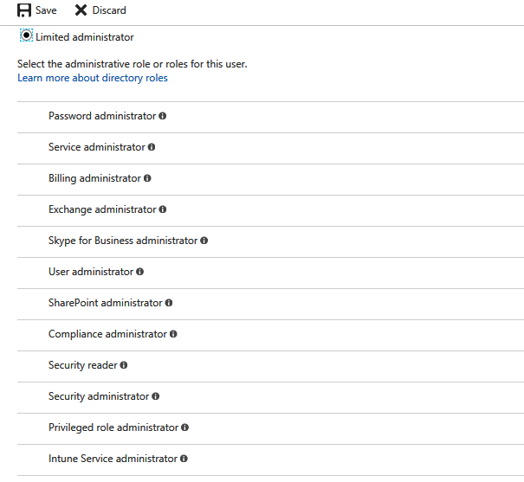

1. Select **Password Administrator**, and click **Save**. After saving, this user will be the Password Administrator.

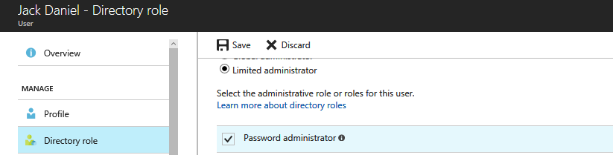

1. Now, he/she can reset passwords for users and other password administrators. So, in this way you can assign roles to a specific user.